- Challenge Name and Category: Head Dump (Web Exploitation)

- Difficulty/Points: Easy

- Description: Welcome to the challenge! In this challenge, you will explore a web application and find an endpoint that exposes a file containing a hidden flag. The application is a simple blog website where you can read articles about various topics, including an article about API Documentation. Your goal is to explore the application and find the endpoint that generates files holding the server’s memory, where a secret flag is hidden. Additional details will be available after launching your challenge instance.

- Flag: picoCTF{Pat!3nt_15_Th3_K3y_59106086}

- Solution/Walkthrough: Taking a look at the news site #nodejs , #swagger UI , #API Documentation links found on the explore backend development with us news block.

The API documentation link redirected me to /api-docs, which hosted Swagger UI which is a tool used to visualize and interact with APIs (Application Programming Interface).
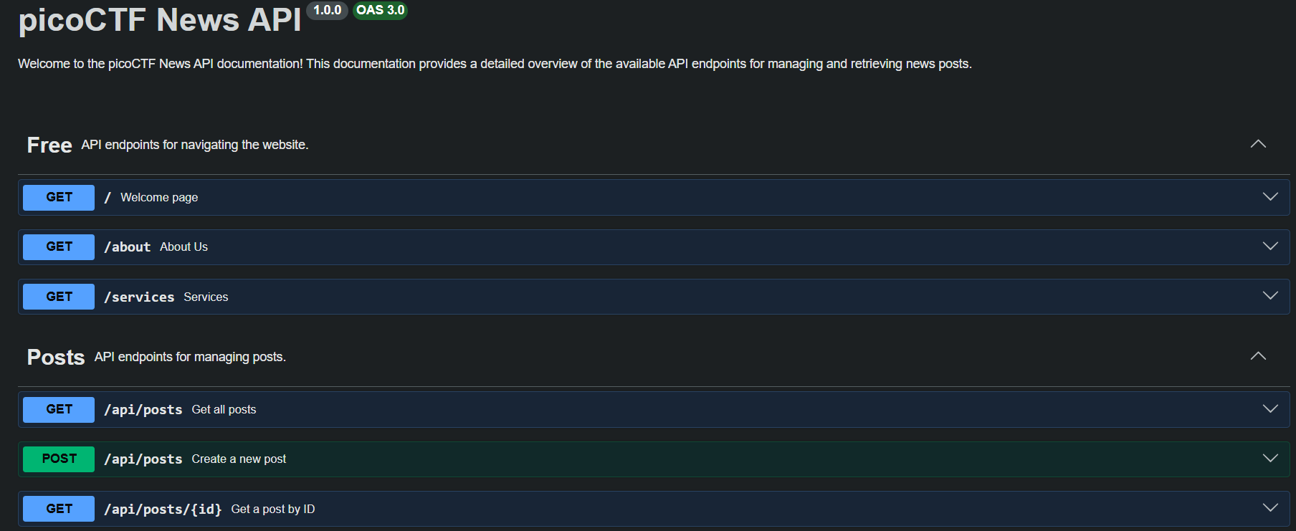
I clicked “try it out” to execute a download for a heapdump file. I was able to wget the file but I could not successfully grep the flag.
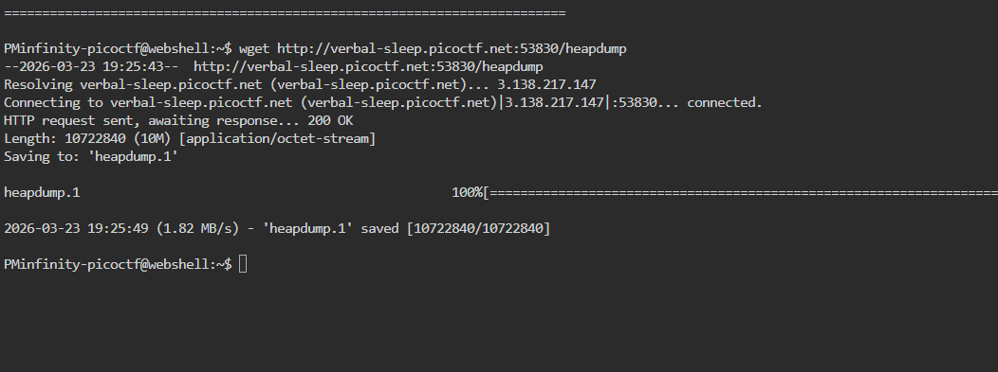
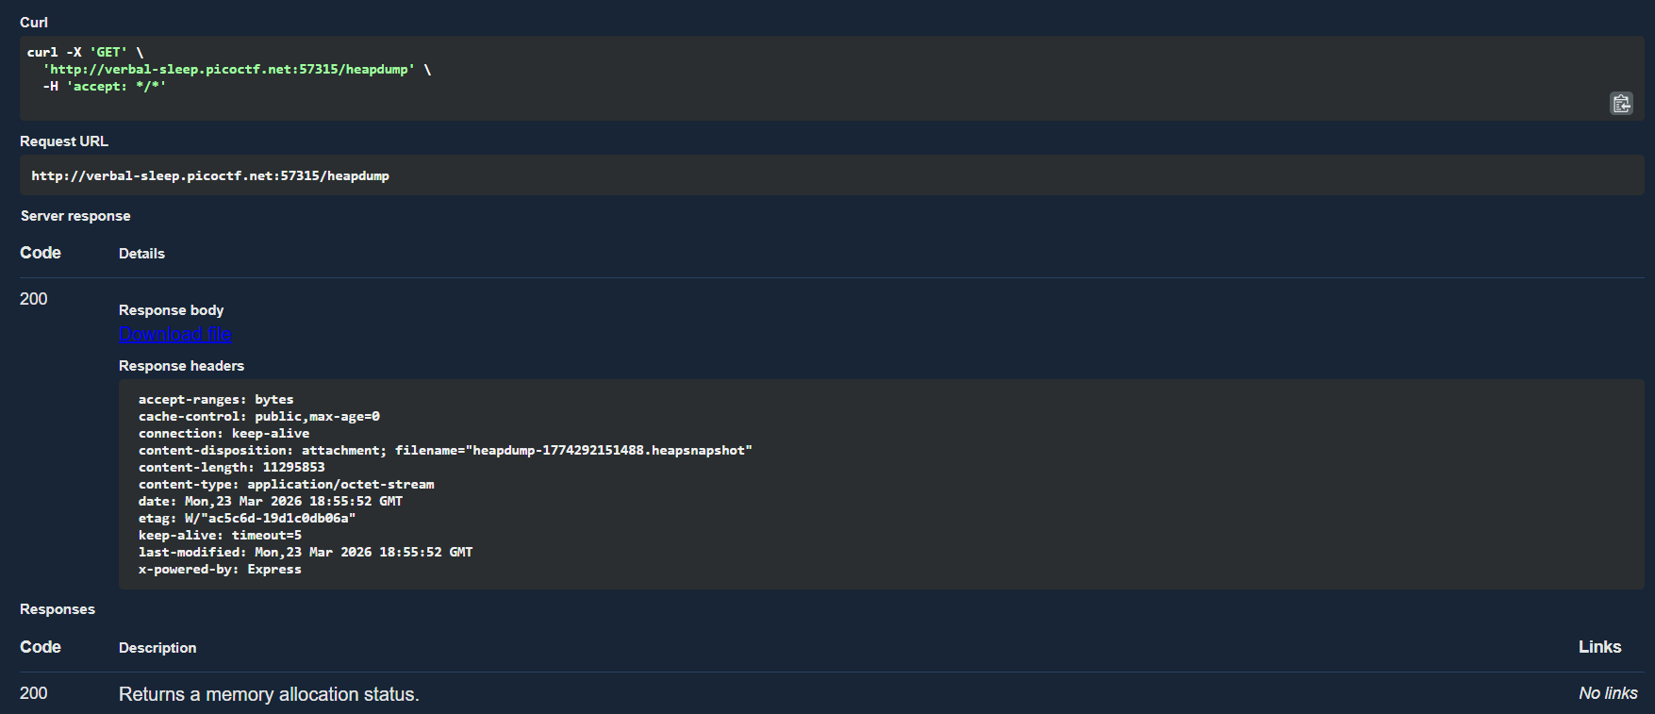
After trial and error, I opened the downloaded file in notebook. Lastly, I had to “control F picoCTF” to find the flag amongst thousands of lines of information.
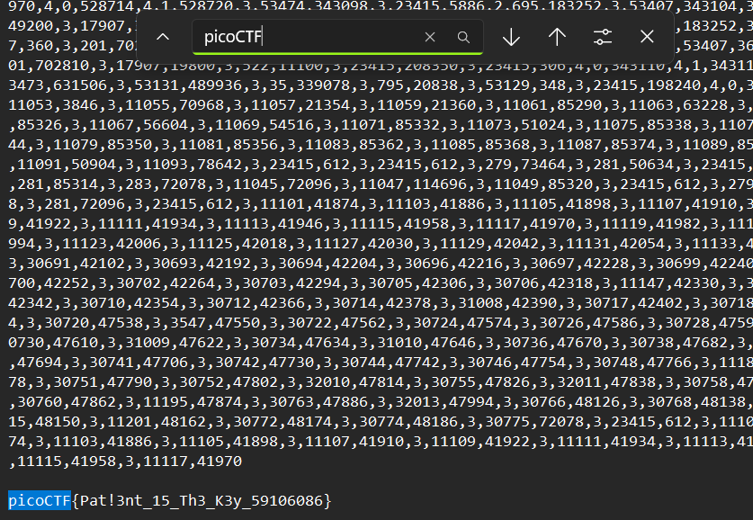
- Tools Used: Web Shell, API doc, notebook.

- Initial Reconnaissance: “Explore backend development with us” was a useful hint that pointed me in the direction of the heapdump.

- Hypothesis Formulation: I had a notion that the dump was going to be very large and unwieldy.

- What Worked vs. What Didn't: I could not issue the correct commands, but the dump itself was easy enough to find. It was just a matter of determining how to identify the flag within thousands of lines. Control find worked for me when I opened the file in notepad.

